Topic: README - EduGATE - Gamma Camera

Author: Uwe Pietrzyk

Research Center Juelich, Germany
Institute of Neurosciences and Medicine (INM-4)
Brain Imaging Physics / PET Detector Technology
&
Department of Mathematics and Natural Sciences /
Medical Physics
University of Wuppertal, Germany

u.pietrzyk@fz-juelich.de
http://www.fz-juelich.de/inm
&
uwe.pietrzyk@physik.uni-wuppertal.de
http://www.medizinphysik.uni-wuppertal.de

Version: 1.0 / September 15, 2011

General Remarks on the setup of the "Gamma Camera System"

The setup is best understood looking at Figure 1:

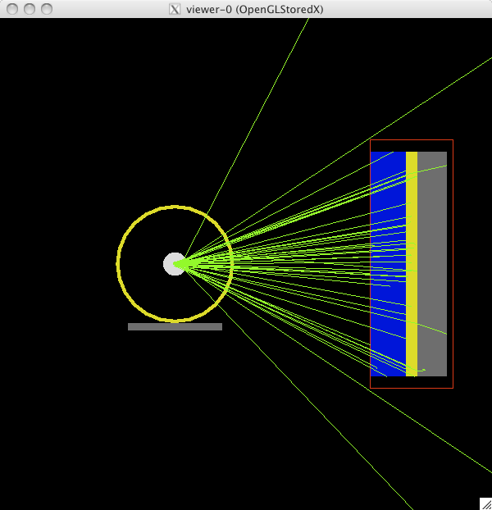

Fig. 1: General setup of the Gamma Camera System as seen from the front,
i.e., looking with the z-axis

The general setup of this "Gamma Camera System" is taken from the benchSPECT example, which comes with the GATE distribution, but has been simplified for the purpose of EduGATE.

Depending on the type of source chosen, gamma rays, electrons, or positrons are emitted from the source(s) at the center of the world-coordinate system. In order to improve the efficiency of the example setup, the emission is limited in phi and theta to direct the gammas or particles to the gamma camera head. Note, this feature does not work for ion sources.

The material of the volume surrounding the source(s) (named source_vol) shown in white can be selected in the configuration file. The same applies for the phantom (i.e attenuating volume) shown in yellow. Here, also the thickness can/should be adjusted by varying the PhanRmax/PhanRmin in order to study the effect of attenuating material on gammas at different energies.

Two collimator types, shown in blue, can be selected, one optimized for gamma energies like that of Tc-99m, i.e. for energies around 141 keV, and another for energies like that of I-131 (major gamma emission line at 364 keV).

The crystal is shown in yellow and the back-compartment is shown in grey. The material of the crystal can be varied in order to appreciate the differences in the interaction of gammas at different energies.

Specific Details:

0) Version GATE: gate_v6.1 / GEANT4: geant4-09-03-patch-02
GATE: gate_v6.0_p01 / GEANT4: geant4-09-02-patch-03
(two physics.com files are provided, one each version)

1) Files

config_starter.sh

(it looks like this:)
#!/bin/csh
# file config_starter.sh
source /Applications/gate_v6.1/env_gate.csh
root -l 'GenerateGateConfiguration.C( "Gamma_Camera.txt" )'
(select/modify your configuration interactively; a new configuration can be saved)
Gate Gamma_Camera.mac

Gamma_Camera.txt
(contains all options that can be set via 'GenerateGateConfiguration.C, see below under (2))

GenerateGateConfiguration.C
(see under “config_starter.sh”)

Main Macro
.../EduGate/Gamma_Camera/Gamma_Camera.mac
-- timing is specified here, using 'TimeSlice' to see progress of simulation
-- only ROOT-output is selected, carrying the source-type in the "RootFileName"

central Macro to set up a specific configuration (via config_starter)
.../EduGate/Gamma_Camera/configuration.mac

switching on/off visualization
.../EduGate/Gamma_Camera/visu.mac
.../EduGate/Gamma_Camera/novisu.mac

macros describing two different collimator setups: I-131, Tc-99m
.../EduGate/Gamma_Camera/camera_I_131.mac
.../EduGate/Gamma_Camera/camera_Tc.mac

defining the phantom surrounding the source
.../EduGate/Gamma_Camera/phantom.mac

define all physical processes
.../EduGate/Gamma_Camera/physics.mac

define primary gamma source
.../EduGate/Gamma_Camera/sources_gamma.mac

select alternative sources of various types
.../EduGate/Gamma_Camera/sources_electron.mac
.../EduGate/Gamma_Camera/sources_gamma_3.mac
.../EduGate/Gamma_Camera/sources_gamma_6.mac
.../EduGate/Gamma_Camera/sources_ion.mac
.../EduGate/Gamma_Camera/sources_positron.mac
.../EduGate/Gamma_Camera/sources_Y90_Histo.mac

ROOT-based analysis Program:
.../EduGate/Gamma_Camera/Gamma_Camera.C
2) Selecting a Configuration, Running Gate and perform an Analysis with Root:

to run the Gamma_Camera example, simply type: config_starter.sh
and a window opens as shown in Figure 2.

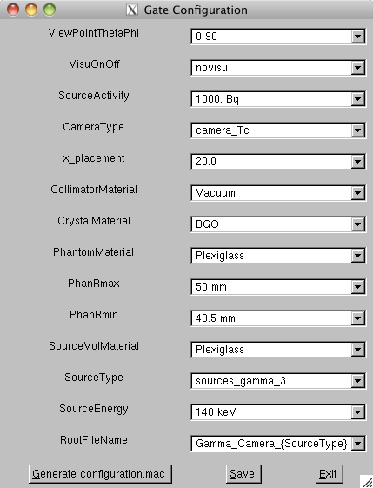

Fig. 2: Interactive selection of a configuration. Click the “Save”-button to store the current settings as default in file “Gamma_Camera.txt” for the future. Click “Generate configuration.mac” to save the current setting in configuration.mac, which after clicking “Exit” will be used for the next run.

You should see lines like:

Processing GenerateGateConfiguration.C( "Gamma_Camera.txt" )...
root [1]
/control/alias ViewPointThetaPhi 0 90
/control/alias VisuOnOff visu
/control/alias SourceActivity 40. Bq
/control/alias CameraType camera_Tc
/control/alias x_placement 20.0
/control/alias CollimatorMaterial Vacuum
/control/alias CrystalMaterial BGO
/control/alias PhantomMaterial Plexiglass
/control/alias PhanRmax 50 mm
/control/alias PhanRmin 49.5 mm
/control/alias SourceVolMaterial Plexiglass
/control/alias SourceType sources_gamma_3
/control/alias SourceEnergy 140 keV
/control/alias RootFileName Gamma_Camera_{SourceType}
End of Configuration

This shows the contents of the file configuration.mac and is used in the Gate run started next.

A collection of possible parameters or options is stored in Gamma_Camera.txt. This file can be edited to include additional parameters that can be selected within the menu.

File: Gamma_Camera.txt

ViewPointThetaPhi: 0 90; 90 0; -90 0; 89 90;
VisuOnOff: novisu; visu;
SourceActivity: 1000. Bq; 40. Bq; 10000. Bq; 100000. Bq;
CameraType: camera_Tc; camera_I_131
x_placement: 20.0;
CollimatorMaterial: Vacuum; Lead; Air; Copper; Iron;Tungsten;
CrystalMaterial: NaI; BGO; LSO; GSO; PWO; LuAP; YAP; CZT;
PhantomMaterial: Plexiglass; Water; Air; Vacuum; Lead; PVC; Copper; …
…Tungsten; Molybdenum;
PhanRmax: 50 mm;
PhanRmin: 49.5 mm;
SourceVolMaterial: Plexiglass; Air; Water; Vacuum; PVC;
SourceType: sources_gamma_3; sources_Y90_histo; sources_gamma; …
… sources_electron; sources_ion; sources_positron;
SourceEnergy: 140 keV; 364 keV; 511 keV; 2284 keV;
RootFileName: Gamma_Camera_{SourceType};

GATE is started and a ROOT-file is created with a name specified in 'configuration.mac'

To run the ROOT-based analysis program, type: root -l Gamma_Camera.C, which can also be directly started from config_starter.sh by adding this line to the script.

A window opens as shown in Fig. 3 and you can select a root file to be analyzed and a file with extension 'gif' is created, storing the displayed plot.

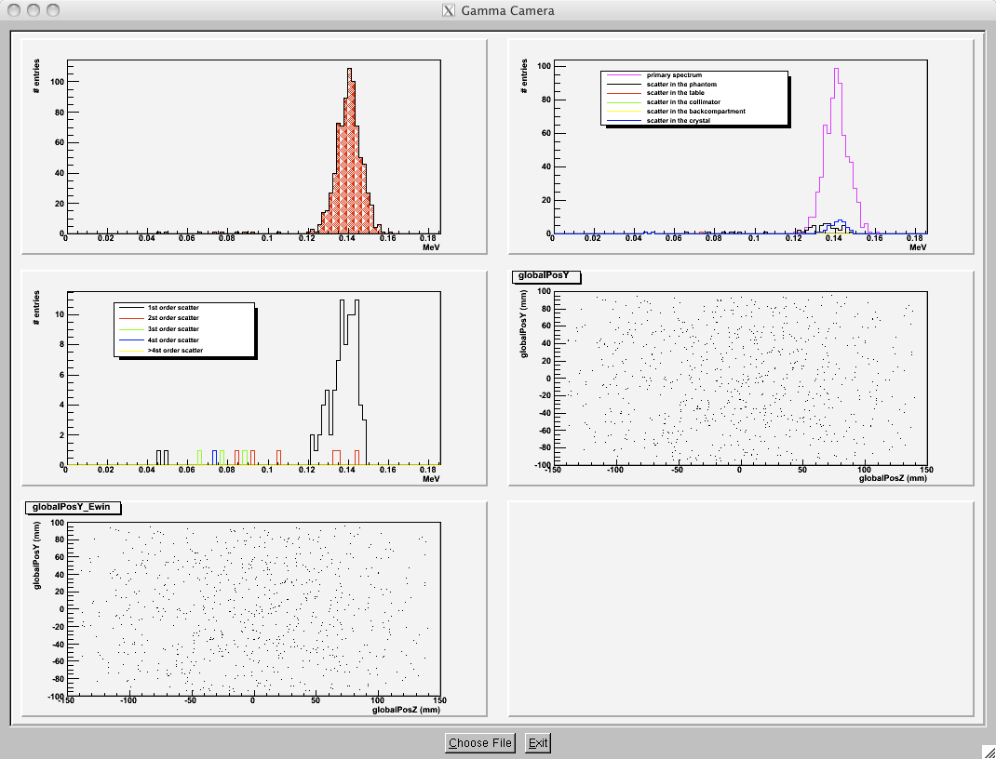

Fig. 3: Starting the root-analysis module (Gamma_Camera.C) will show
(after the selection of a root file) some plots previously defined in the module.

The output in the terminal window will also provide some statistics, as shown below:

##### Reading from file: Gamma_Camera_sources_gamma_3.root

Info in <TCanvas::Print>: GIF file Gamma_Camera_sources_gamma_3.gif has been created
***********************************************************************************
* *
* E d u G a t e S i m u l a t i o n A n a l y s i s *
* G A M M A C A M E R A *
* *
***********************************************************************************

##### Number of emitted particles : 120255
##### Number of detected events : 5159 events
##### Primary events : 23.6674 %
##### Scatter in the phantom : 0.0775344 %
##### Scatter in the table : 0 %
##### Scatter in the collimator : 14.3245 %
##### Scatter in the crystal : 31.0525 %
##### Scatter in the backcompartment : 28.5327 %

##### Scatter order 1 : 44.5912 %
##### Scatter order 2 : 29.482 %
##### Scatter order 3 : 13.7125 %
##### Scatter order 4 : 6.83088 %
##### Scatter order >4 : 5.38344 %

